Individual Skill: Backrow moves
Skill:
Handling and decision making.
Set up:
5m square, player ‘A’ leads attack, ‘B’ picks up the ball. ‘X’ defends. Ball is placed just inside the marker. ‘A’ checks ‘X’ & delivers to ‘B’ or tries to beat ‘X’.
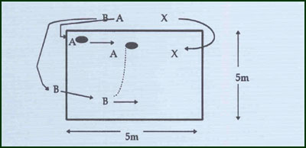
Key Factors:
· Correct angle i.e. inside shoulder.
· Speed of running & correct timing of pass i.e. close to opposition.
Progression:
· 3 attackers i.e. player ‘C’ who supports A at depth on the inside, & 2 defenders to simulate No. 8 Blindside flanker i.e. X & Y. use wider grid 8m by 5m long.
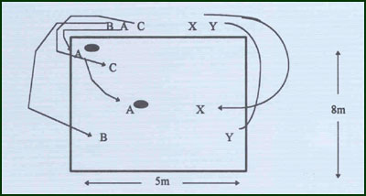
Groups:
Minimum of 3 players, maximum 5.

